ICC Summer Camps - June 8th - 12th, 2026
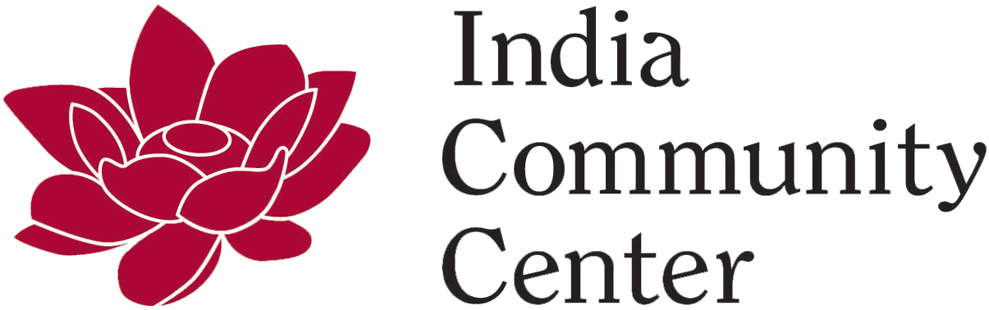
ICC Summer Camp 2026 - PHOTOS (Click for access to photos)

Day 1
Morning Snack -
Lunch -
Afternoon Snack -

Day 2
Morning Snack -
Lunch -
Afternoon Snack -

Day 3
Morning Snack -
Lunch -
Afternoon Snack -

Day 4
Morning Snack -
Lunch -
Afternoon Snack -

Day 5
Morning Snack -
Lunch -
Afternoon Snack -

STE(A)M, Sports & Art Camp (5 - 7 yrs)

Day 1
Add camp details and pictures here

Day 2
Add camp details and pictures here

Day 3
Add camp details and pictures here

Day 4
Add camp details and pictures here

Day 5
Add camp details and pictures here

Jr. Robotics, Art & Sports Camp (6 - 8 yrs)

Day 1
Add camp details and pictures here

Day 2
Add camp details and pictures here

Day 3
Add camp details and pictures here

Day 4
Add camp details and pictures here

Day 5
Add camp details and pictures here

Neo Space Bots & Canva Art Camp (8 - 12 yrs)

Day 1
Add camp details and pictures here

Day 2
Add camp details and pictures here

Day 3
Add camp details and pictures here

Day 4
Add camp details and pictures here

Day 5
Add camp details and pictures here

Kathak, Public Speaking, Debate & Chess Camp (6 - 15 yrs)

Day 1
Add camp details and pictures here

Day 2
Add camp details and pictures here

Day 3
Add camp details and pictures here

Day 4
Add camp details and pictures here

Day 5
Add camp details and pictures here

College Readiness - Journey towards Excellence (13 - 16 yrs)

Day 1
Add camp details and pictures here

Day 2
Add camp details and pictures here

Day 3
Add camp details and pictures here

Day 4
Add camp details and pictures here

Day 5
Add camp details and pictures here

